APCO ACTION PLAN 2026

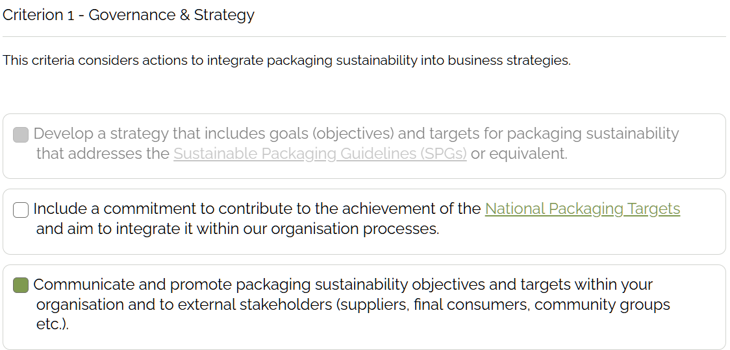

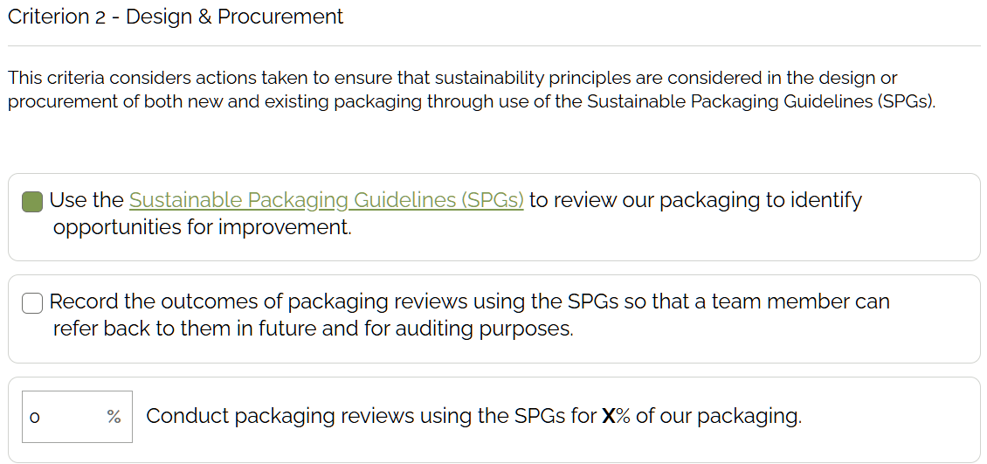

Comment: As reported on the APCO Annual Report the last few years, design and material used on all packaging has been optimized and no further modifications can be done. The raw material used on all packaging is the least specifications to fit purpose and intended use.

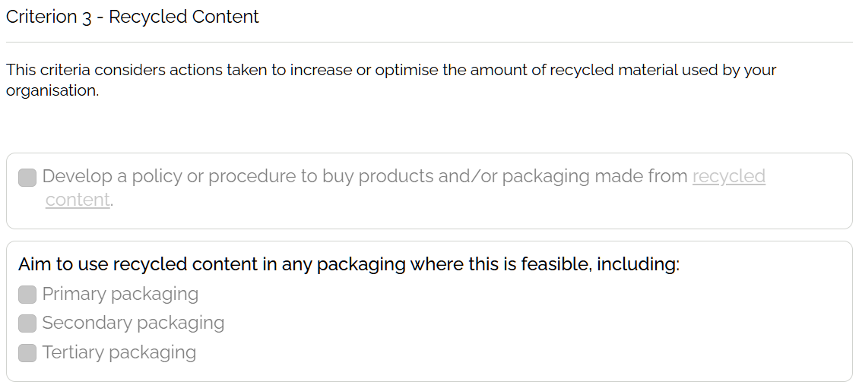
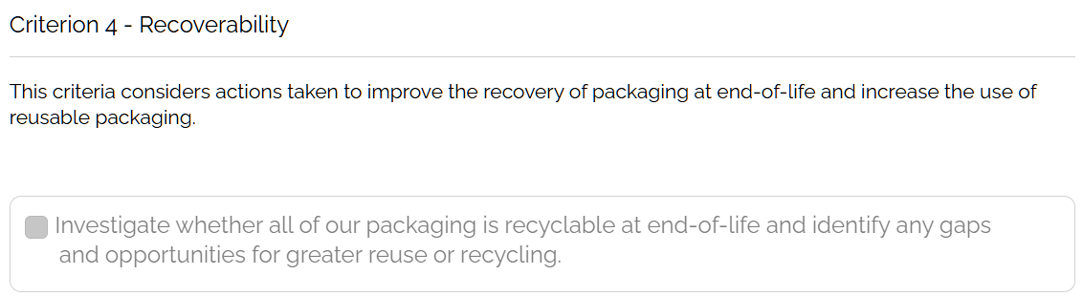

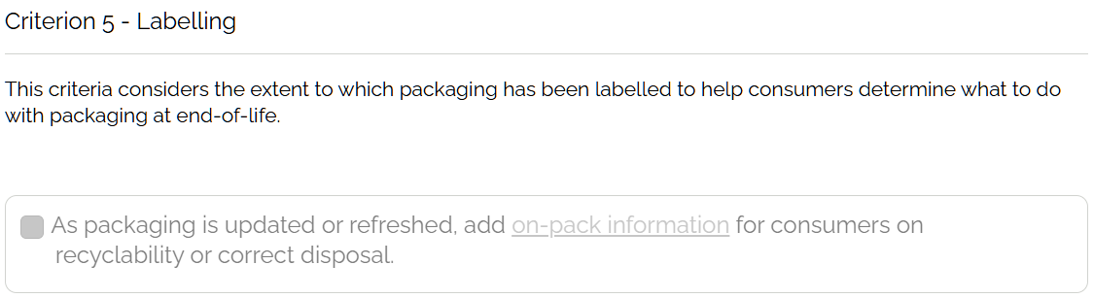

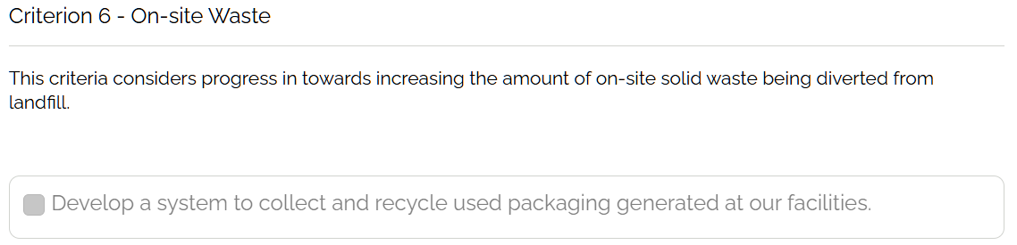

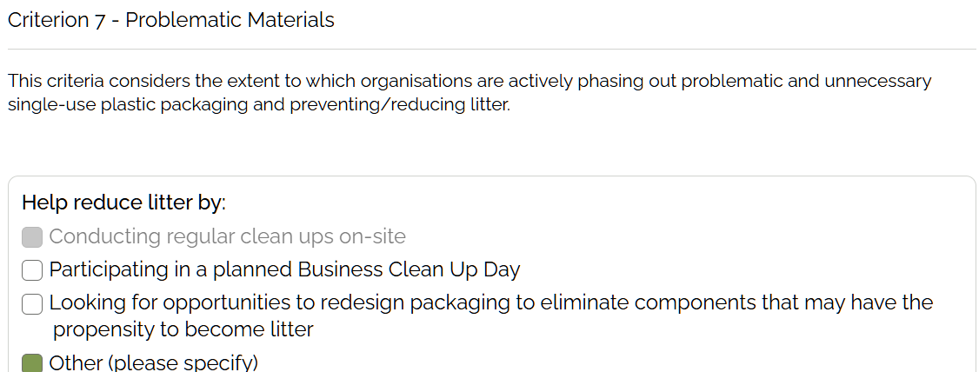
Comment: All waste are placed on designated bins, sorted and collected for proper disposal by a Suez, third party contractor.
Visy Board collected and recycled all cardboard & corrugated boxes.
Records are available in Finance.
From previous years report (point 2) we have optimized packaging designs and cannot do any other modifications. The material used on all packaging are also the least specifications that will fit the intended use.

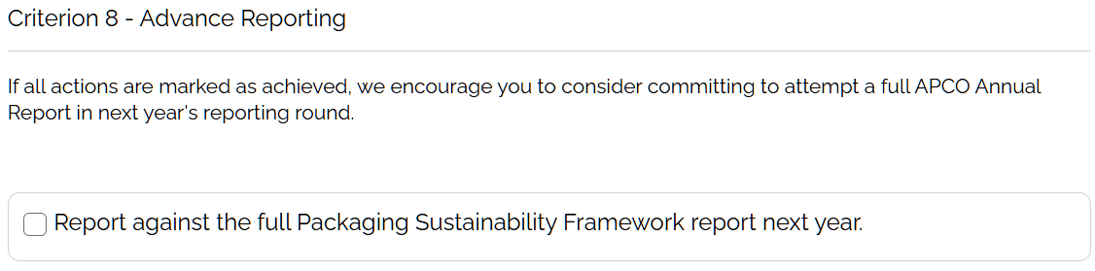
Comment: This criterion will be considered in the future if all of the sub-criterions are completed

